JazzLeeds Charity 2020 Annual Report

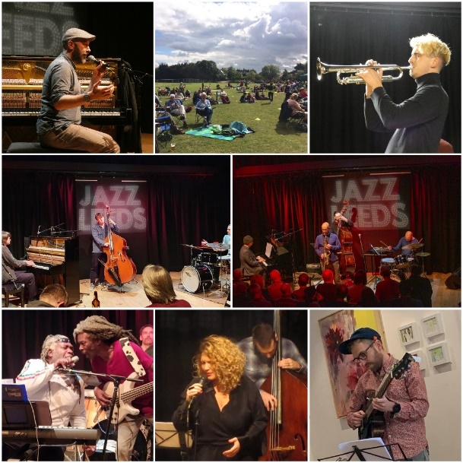

Henry Botham, Jazz Picnic, Tom Sharp, Fergus McCreadie trio,

Ethan Iverson and Martin Speake, Bluebirds, Emilia Martennson, Eirk Svela

The Covid pandemic has made it a difficult year for everyone involved in live music. We're glad we've helped to keep the live scene going in Leeds by putting on over 40 concerts of which 34 of which were Leeds based bands. We also managed to host a few international big names too. This report covers a number of different aspects of the year.

Women Jazz Leaders series. Between October - December 2020 we held our first Women Jazz Leaders series – 12 groups played in total. It was well received by audience and performers alike.

- Rosie Turton “5ive” @Seven Arts with Hannah Hutton Quintet in support 10-Oct
- ARQ @ Inkwell 13-Oct
- Katherine Windfeld Sextet @ Seven 20-Oct
- Maria Chiara Argirò group featuring Leila Martial @Seven Arts with Da Hora in support 24-Oct
- Kathy Ibberson Band @ Inkwell 27-Oct
- Ysbryd @ Inkwell 17-Nov
- Jensen Sisters / Whirlwind Recordings Orchestra @Seven Arts 21-Nov
- Kim Macari/Jon Pope Duo @ Inkwell 01-Dec
- Karen Sharp Quartet @Seven Arts with Harmony Row 05-Dec
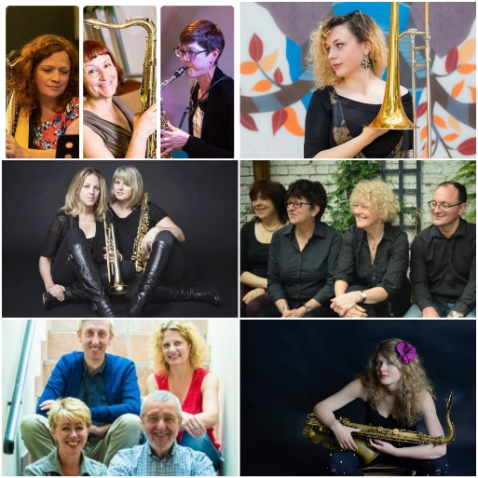

Roundhay Golf Club
The autumn of 2019 saw our last four concerts at the Roundhay Golf Club venue.
Kate Peters Quintet 13-Sep
Leeds Jazz Orchestra 11-Oct
Greg Abate Quartet 08-Nov
Chapel FM big band Roundhay 13-Dec
The venue had a number of problems which led to us ceasing to put concerts on – our audiences were not particularly high for a Friday evening – averaging just 42. The acoustics were no particularly good. The venue didn’t attract a new audience – it was mostly our existing audience from Seven and Inkwell.

Other Autumn and Spring Bands
Apart from the Women Jazz Leaders series we also put on a number of other groups in the autumn and early spring.
Ancient Infinity Orchestra @ Seven 08-Sep
Eastgate Acoustic Basie Big Band @Seven 29-Sep
Jam Experiment/Bonsai @Seven 06-Oct
Inji Bjarni Trio @ Inkwell 03-Nov
Sam Rapley’s “Fabled” @ Seven 10-Nov
Enrico Machesi’s “Cuegno” @ Seven 24-Nov
Fergus Quill’s “Tribute to Miles” @ Seven 08-Dec
Winter Jazz Café @ Inkwell17-Dec
Tom Sharp Big Band Xmas Party @Seven Arts 19-Dec
New Year Jazz Café and Jam @Inkwell 5 Jan
Em Brown Quintet @Seven Arts 12 Jan
Teena Lyle Quintet @Inkwell 19 Jan
Gary Boyle Quartet @Seven Arts 26 Jan
Jeff Hewer Trio @Inkwell 2 Feb
Emilia Mårtensson group with Suppertime @Seven Arts 6 Feb
Soul Surgeons @Seven Arts 9 Feb
Ethan Iverson/ Martin Speake Quartet @Seven Arts 15 Feb
Ed Kainiek Quartet @Seven Arts 16 Feb
Eirik Svela Quintet @Inkwell 23 Feb
Zoe Gilby Quartet @Seven Arts 1 Mar
Lockdown Jazz
The first country wide Covid 19 lockdown was imposed in March 2020. There was no possibility of live jazz. We went online and created a total of 18 Jazz Leeds videos of both archive and new material, and broadcast four radio programmes with ChapelFM about the Leeds Jazz Scene in lockdown. We also organised several "living room" recordings broadcast via our YouTube site with live sessions from Lawrence Marshall and Phoebe Douthwaite, Jeff Hewer, Nicki Allen, Chris Lloyd, Jenny and Jon Chamberlain and Ed Barnwell. No workshops or jazz choir sessions during the pandemic, although tutors Dom Moore and Tessa Smith continued to provide lessons online

From July 2020, we went back to live music again - not just the only jazz club in Leeds but in fact the only one anywhere in the UK putting on gigs, a real achievement in adversity. In total we put on over 40 bands, or whom 34 were from the local Leeds area. In addition we held three jazz café and jam sessions at Seven Arts who were really helpful to us in ensuring social distancing and at-table service for the concerts. The Inkwell venue unfortunately remained closed during the lockdown. A list (with some embedded video links) of the people that played live for us during 2020 is below Most of the gigs were outside in the Seven Arts courtyard (marked **). One or two were inside due to the weather.

**Will Powell Trio July 5 July
**John Settle Quartet 12 July
**Manouche North 19 July
**Derrick Harris trio 22 July
**Sam Jackson and Harry Orme 26 July
**Rebecca Frodsham/Jeff Hewer Quartet 29 July
**Washboard Resonators 2 Aug
**Jazz Café and Jam Session 9 Aug
**Nicki Allen Quartet 12 Aug
** Hyde Park Brass 16 Aug
**Toby Jack Brazier group 19 Aug
Ben Powling Quartet 23 Aug
**Emma Johnson’s Gravy Boat 26 Aug
**John Taylor’s Blues Dudes 30 Aug
**Rory Ingham+Dom Ingham+Jonny Mansfield+Will Harris 9 Sept
**Jennie Hammond sings Blossom Dearie 13 Sept
**Will Howard Trio 16 Sept
**Jazz Café and Jam Session 20 Sept
Svarc-Hanley-Longhawn Sept 23
Tom Sharp Quartet's tribute to Clifford Brown Sept 27
The Bluebirds Oct 4
Ends and Means (Jamie Taylor/Ben Lowman) Oct 11
Kate Peters Quartet Oct 14
Catimba Oct 18
Henry Botham Oct 25
Fergus McCreadie Trio 29 Oct
Jazz Café and Jam Session 1 Nov

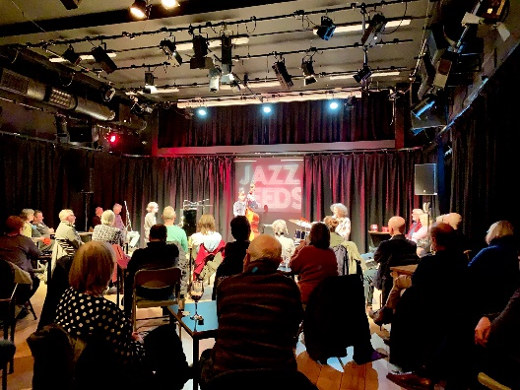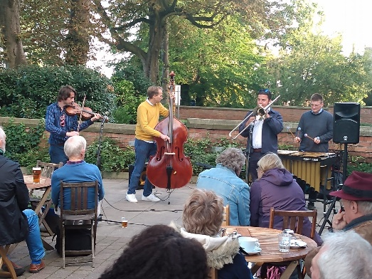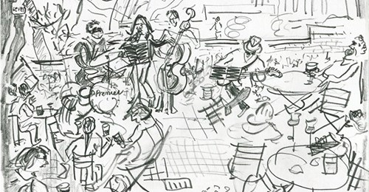

The Jazz Box
Jazz Leeds contributed towards the cost of streetscene/street improvement in our home area of Chapel Allerton by paying for the artist Ekatrina Sheath to paint one of the BT communication boxes in Regent Street where we have organised the Jazz Sundays at the Chapel Allerton Arts
Festival. It was completed in time for the Flying High Festival and we had a live band to perform to mark the occasion.

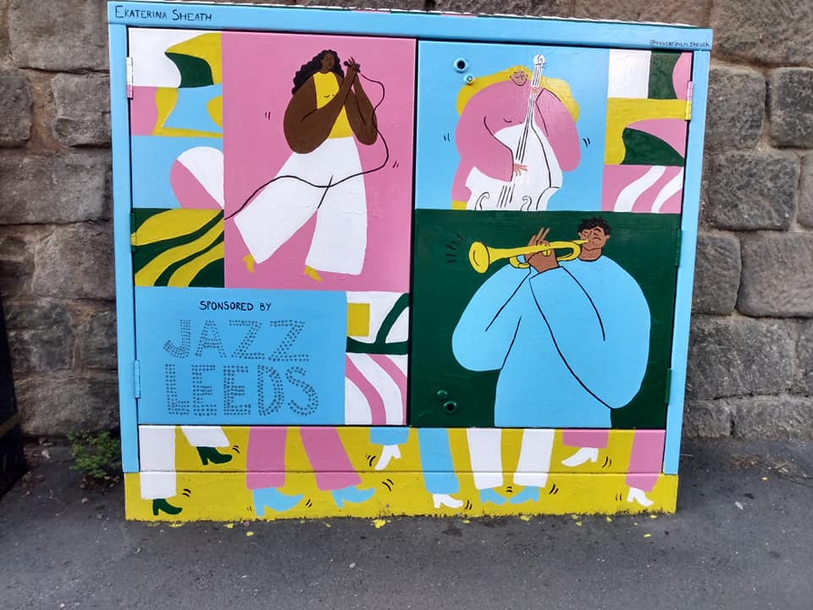

Flying High Jazz Festival and Jazz Picnic 2-6 September 2020.
With no JazzLeeds Festival or Chapel Allerton Festival possible, we decided to try out a smaller open-air Festival at Seven Arts courtyard culminating in a JazzPicnic at Gledhow Sports Club. The aim was lifting people’s spirits and with over 300 people attending over the three evenings and one afternoon it did just that. Each group had their own space marked out on the sports field.

The bands booked were:
Eliot Richards “Meantime” 2 Sept
** Tshok 4 Sept
** Bassa Bassa 5 Sept
** Washboard Resonators 6 Sept
** Rhythm de Luxe 6 Sept
** Alice Higgins Trio 6 Sept
** Jeremy Sassoon Quartet 6 Sept
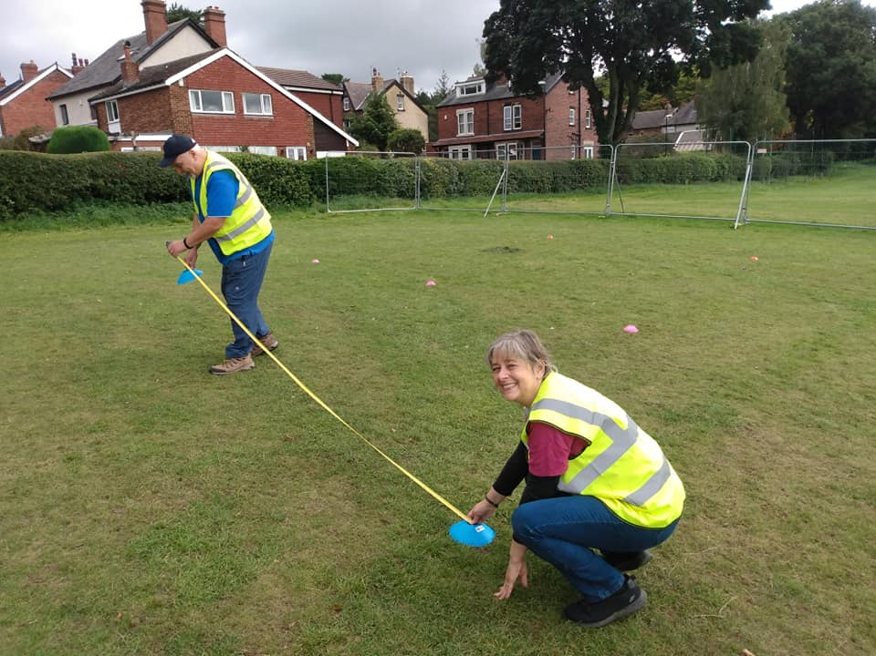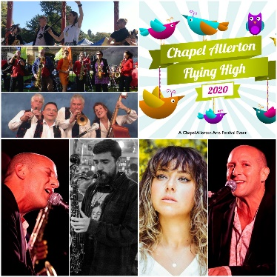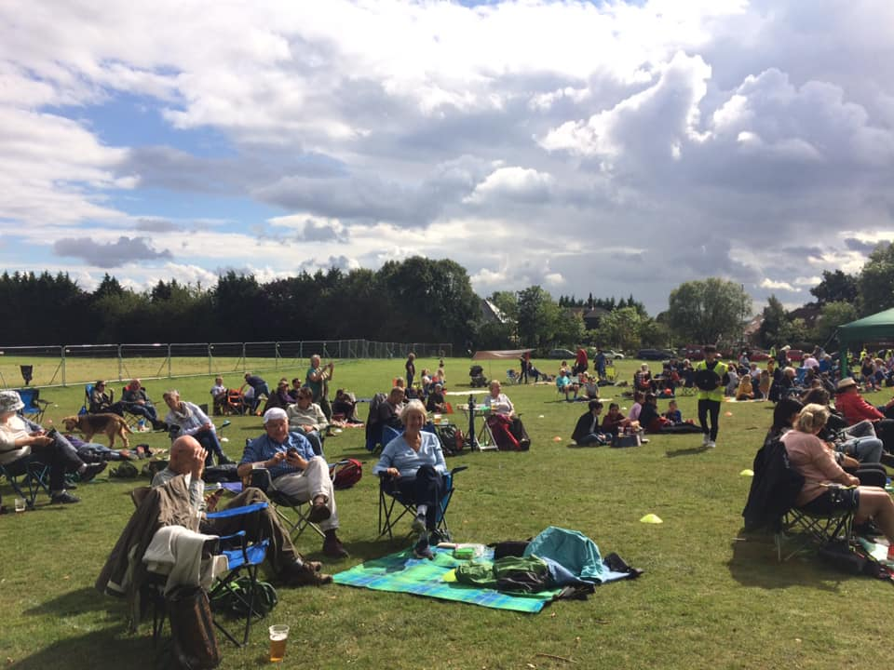

Thanks
Many thanks are due - to Seven Arts for allowing us to put the gigs on there, to Gledhow Sports Club who hosted our Flying High Jazz picnic in September, to Chapel FM for co-producing the Jazz Unlocked Radio shows, to Leeds Inspired and Arts at Leeds for funding us, Music Leeds and Jazz North for their encouragement, Jo Dunn for her gig paintings (one of these is illustrated above), for Inkwell and Roundhay Golf Club for hosting us in the early part of the year and last but not least to our jazz volunteers and supporters - we couldn't have got though the year without them.
Steve Crocker
Chair JazzLeeds Trustees
May 2021

